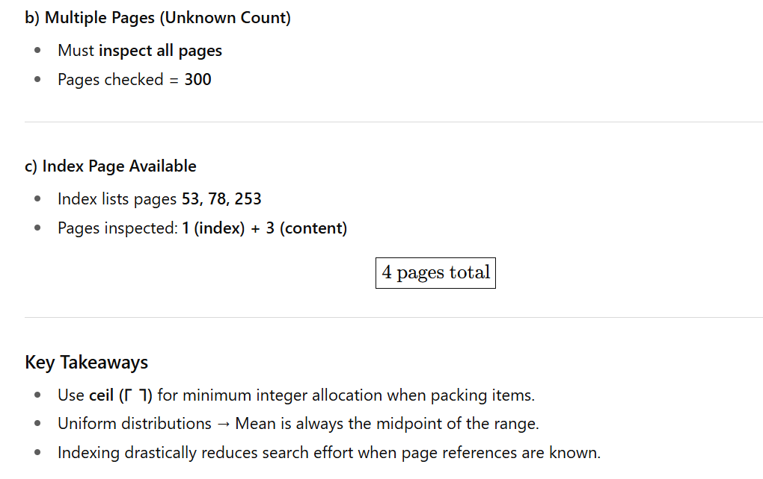
set of questions in a similar style
Implementation of DBMS
Exercise Sheet 1b
Kln., WS 2023 / 2024
1) Probability and Statistics
We have a uniformly distributed random variable Y that can take integer values in the range [50, 150].
What is the mean of Y?
2) Storage and Containers
a) We have boxes that can hold up to 8 books. We have 90 books and want to store all of them in the boxes.
What is the minimum number of boxes that we need?
b) We have 34 jars. Each jar contains 3 kg of flour. We want to transfer all the flour into large containers that can hold up to 10 kg each.
What is the minimum number of large containers needed?
3) Distance Measurement
A hiking trail starts from kilometre 3 and ends at kilometre 25.
How many kilometres have you hiked in total?
4) Search Operations in a Database
You have a database with 500 records. You want to find entries related to a specific keyword. The keyword might appear in multiple records.
a) You know that exactly one record contains the keyword. How many records do you need to inspect to find all relevant information? Consider the minimum, maximum, and mean number of searches.
b) There could be multiple records that contain the keyword, but you do not know how many. How many records do you need to inspect to ensure you retrieve all relevant information? Consider the minimum, maximum, and mean number of searches.
c) Assume that the database has an index table that lists the records containing the keyword. The index tells you that the keyword appears in records 45, 132, and 287.
Using the index, how many records do you have to inspect?

Implementation of DBMS
Exercise Sheet 1c
Kln., WS 2023 / 2024
1) Probability and Statistics
We have a uniformly distributed random variable Z that can take integer values in the range [10, 200].
What is the mean of Z?
2) Storage and Packing Problems
a) We have bags that can carry up to 10 apples. We have 95 apples and want to pack all of them into bags.
What is the minimum number of bags needed?
b) We have 40 bottles, each containing 1.5 liters of juice. We want to pour all the juice into large dispensers, where each dispenser can hold up to 6 liters.
What is the minimum number of dispensers required?
3) Distance Calculation
A railway route starts at kilometre 7 and ends at kilometre 45.
How many kilometres is the train journey?
4) Searching in a Digital Archive
You have a digital archive containing 1,000 documents. You want to locate documents that mention a specific topic.
a) You know that exactly one document contains the required information. How many documents do you need to check to find it? Consider the minimum, maximum, and mean number of searches.
b) There could be multiple documents that mention the topic, but you do not know how many. How many documents do you need to search to retrieve all relevant information? Consider the minimum, maximum, and mean number of searches.
c) Suppose the archive has a search index, which tells you that the topic appears in documents 102, 435, and 789.
How many documents do you need to examine using this index?

Implementation of DBMS
Exercise Sheet 1a
Prof. Kln., WS 2024/2025

- We have a continuous random variable Y that is uniformly distributed in the range [0,50]. What is the meaning of Y?
- a) A storage bin can hold up to 15 books. If you have 250 books, what is the minimum number of storage bins required to store all of them?
b) You have 45 liters of juice in 3-liter bottles. You want to pour all the juice into containers that can hold up to 10 liters each. What is the minimum number of containers you need?
c) You need to store rubber balls with a diameter of 50mm. Each box can hold balls up to a height of 100mm, width of 100mm, and length of 450mm. What is the minimum number of boxes required to store 200 balls?
- You have a PDF document with 500 pages, and you are searching for all references to a specific term. The references could be randomly placed across pages.
a) If there is exactly one page that contains this term, how many pages would you need to search? Consider the minimum, maximum, and mean number.
b) If the term could appear on any number of pages, but you don’t know how many, how many pages would you need to search to find all references? Consider the minimum, maximum, and mean number.
c) Suppose the last page contains a keyword index, listing all pages with references for various terms, and it specifies that the term appears on pages 101, 235, and 432. Using the index, how many pages do you need to search to find all references to the term?

DBMS – Exam Questions Based on Exercise Sheet 1

Section A: Multiple Choice Questions (MCQs)
1. Uniform Distribution Basics
A random variable XX takes integer values uniformly from 1 to 200. What is the mean of XX?
a) 100
b) 100.5
c) 200
d) 101

2. Packing Bottles
You have 55 bottles and crates that hold 12 bottles each. What is the minimum number of crates required?
a) 4
b) 5
c) 6
d) 7

3. Searching Without Index
If a keyword may appear on multiple pages in a 400-page book and no index is available, how many pages must you check to be certain you found all mentions?
a) 1
b) 200
c) 400
d) It depends on the keyword frequency

4. Table Tennis Balls
A box has dimensions 40mm x 40mm x 250mm. Each table tennis ball has a diameter of 40mm. How many balls fit in one box?
a) 5
b) 6
c) 7
d) 8

5. Using an Index
If a book has 500 pages, and the index shows the keyword appears on pages 23, 75, and 420, how many pages will you inspect to find all information?
a) 3
b) 4
c) 5
d) 6

Section B: Short Answer
6. Mean Calculation
Explain the formula for calculating the mean of a uniformly distributed random variable over a range [a, b], and compute the mean if the range is [10, 60].

7. Packing Calculation
You need to distribute 245 bottles into crates that hold 12 bottles each. How many crates are required?

8. Searching a Book
A book has 350 pages. You know exactly one page contains the keyword. What is the minimum, maximum, and mean number of pages you will check?

9. Searching with Index
A book has 400 pages and an index listing pages 17, 120, 250, and 399 for a keyword. How many pages will you inspect, and why?

Section C: Applied Problems
10. Packing and Space Optimization
You have 180 table tennis balls (diameter: 40mm) and boxes with dimensions 40mm (height) × 40mm (width) × 320mm (length).
- (a) How many balls can you fit in one box?
- (b) How many boxes will you need?

11. Database Log Search
A database system generates logs split into 300 segments. You know exactly one segment contains an error code.
- (a) What is the mean number of segments to check if you scan sequentially?
- (b) How many segments must you check if you cannot stop early?

12. Real-Life Scenario
A library system maintains an index of book locations: each keyword points to an average of 5 books.
- (a) If you want to find all books for the keyword “hashing,” how many records will you inspect (including the index)?
- (b) Compare the effort with the case when no index exists.

